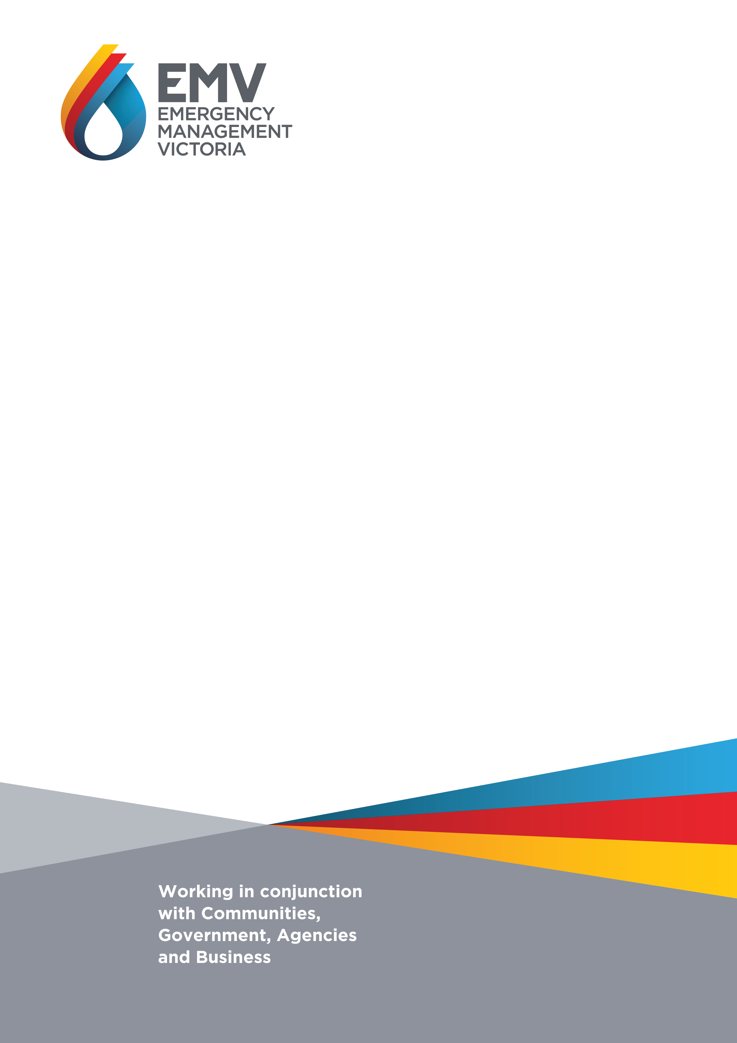
Building a safer & more resilient community in Morwell & the Latrobe Valley

Project Plan - for distribution
May 2017

1. Definitions 3
2. Executive Summary 3
3. Background 3
4. The Problem 3
5. Aim and Objectives 3
6. Methodology 3
7. Scope 3
8. Outputs 3
9. Expected Outcomes 3
10. Expected Benefits 3
11. Stakeholder Engagement and Communications 3
12. Implementation 3
13. Evaluation 3
14. Governance 3
Attachment 1: Project risks and analysis tables 3

Audience
The primary audience for this document are the Key Stakeholders identified on page 8.
Note: Individual names and contact details have been removed.

1. Definitions
Table 1. Definitions
Acronym | Definition
AV | Ambulance Victoria
CALD | Culturally and Linguistically Diverse communities
CBEM | Community Based Emergency Management
CEMP | Community Emergency Management Planning
CFA | Country Fire Authority
CMY | Centre for Multicultural Youth
CRC | Community Recovery Committee
DELWP | Department of Environment, Land, Water and Planning
DET | Department of Education and Training
DHHS | Department of Health and Human Services
DPC | Department of Premier and Cabinet
EM | Emergency Management
EMV | Emergency Management Victoria
EMC | Emergency Management Commissioner
EPA | Environment Protection Authority
IGEM | Inspector General for Emergency Management
LCC | Latrobe City Council
LHA | Latrobe Health Assembly
LVA | Latrobe Valley Authority
MEMPC | Municipal Emergency Management Planning Committee
MNH | Morwell Neighbourhood House
NGO | Non-Government Organisation
NFP | Not for Profit Sector
SAP | Emergency Management Strategic Action Plan
VICSES | Victoria State Emergency Services
VotV | Voices of the Valley

2. Executive Summary
On 9 February 2014, embers from a number of bushfires ignited the Hazelwood Mine Fire near Morwell in the Latrobe Valley. Despite major suppression efforts the coal mine continued to burn for 45 days, with severe consequences including an emotionally and physically exhausted community in Morwell.
An independent Board of Inquiry was established to consider the impacts of the complex fire and public health implications. The Hazelwood Mine Fire Inquiry Report (2014) identified 18 recommendations, including Recommendation 12 as the key driver for this project:
‘The State, led by Emergency Management Victoria, develop a community engagement model for emergency management to ensure all State agencies and local governments engage with communities and already identified trusted networks as an integral component of emergency management planning.’
Whilst this recommendation was generally supported by key stakeholders, local residents voiced concerns about issues not fully addressed in the initial inquiry. In May 2015 the inquiry was reopened to investigate whether the Hazelwood Mine Fire led to poorer health outcomes and increased deaths. It also considered how to potentially improve the health of the Latrobe Valley community, together with opportunities to increase community safety and resilience levels.
A series of engagement processes during this time identified that connections between agencies, organisations and the community were difficult to establish during the fire. Local residents also highlighted how difficult it was to make their voices heard and that these experiences reinforced an underlying lack of trust between the community, government and organisations.
The Hazelwood Mine Fire Inquiry: Victorian Government Implementation Plan (2016) was released to provide further direction toward supporting the community. This upheld the priority to complete Recommendation 12, together with the employment of an Engagement Officer to use the Community Based Emergency Management (CBEM) approach, to guide the planning and engagement processes in Morwell and the Latrobe Valley.
By June 2017, this project will have supported the Morwell community (and by June 2018 the wider Latrobe Valley community) and organisations to better connect and work together before, during and after emergencies by:

- Connecting people and networks
- Using local knowledge
- Understanding long term stresses and the potential impacts from shocks
- Developing goals and solutions, and
- Continuing to learn, share and improve.

3. Background
The Victorian Emergency Management sector is undergoing significant reform. This includes enabling communities to become safer and more resilient.
The development of a modern emergency management system in Victoria includes creating opportunities for communities to use their initiative in better connecting and work together before, during and after emergencies. The CBEM approach supports communities and organisations to achieve this by building on combined strengths, while better collectively managing chronic stresses (such as drought, economic disadvantage) and coping with acute shocks (e.g. bushfire, storm, flood, landslide, earthquake), including emergencies.
This collaborative strengths based approach was piloted with the local community in Harrietville and is being adopted by a range of communities and organisations throughout Victoria. The key drivers for introducing this approach to communities in Morwell and the Latrobe Valley are Recommendation 12 of the Hazelwood Mine Fire Inquiry Report (2014); and the community engagement priorities identified in the Hazelwood Mine Fire Inquiry: Victorian Government Implementation Plan (2016).
Adopting and using the CBEM approach recognises that community members are knowledgeable and should participate in the decision making processes that affect them. Current engagement processes in Morwell have identified that local people are willing to participate in discussing their challenges and developing solutions through this approach.
The Morwell and Districts Community Recovery Committee was created to support the community through these types of processes following the Hazelwood Mine Fire. Further advice from this group and other stakeholders supports the need for this project. This includes connecting local networks with agencies and organisations, so that the community can be better prepared to manage chronic stresses and cope with acute shocks, including future emergencies. It is expected that the experience and key learnings from the Hazelwood Coal Mine Fire will influence this project, but will not remain the focus.
The intent of this project is to empower the community in Morwell and Latrobe Valley to take the lead in adapting and using the CBEM approach, together with the support of agencies, government, business, industry and non-government organisations including those in the not for profit sector.
This project will adopt and use the CBEM approach to support a range of people and processes that are already underway. This includes guiding people to work together, build on combined strengths and use their networks to improve their current situation, while reducing vulnerabilities and laying the foundation to become safer and more resilient over time.
These are complex processes and an Engagement Officer has been employed to work locally with key stakeholders in Morwell and the Latrobe Valley as part of this project. Working together to identify, respect and appropriately support people to address their local community needs, is a key contribution toward building safer and more resilient communities throughout Victoria.

4. The Problem
The Hazelwood Coal Mine fire severely impacted the community in Morwell and Latrobe Valley in many ways. The scale of the emergency and impacts from smoke exhausted the ability for local people and supporting organisations to cope. Assistance was required from external volunteers and experts from other regions, interstate and overseas. Many community members in Morwell found communication about the emergency response and the potential impacts of the smoke to be inconsistent and confusing. This experience has left the community with questions about what happened, what could have been done better and what should be in place to better prepare, respond and recover from future emergencies.

What Problem are we trying to solve?
- The lack of understanding about how the community and organisations can better connect and work together to manage future emergencies.

Who have experienced these problems?
The people who have experienced these impacts and consequences include:
- Local community members and residents
- Volunteers and staff from community organisations
- Volunteers and staff from Emergency Management agencies
- Government organisations including Latrobe City Council, management and staff
- Local business and industry, and
- NGOs and NFPs.

Why is this a problem?
The local community is still dependant on agencies and feel removed from the decision making process that affect them. An apparent lack of trust, together with experiences associated with the Hazelwood Mine Fire have eroded community confidence in government and organisations to:
- Support the community to recover from the consequences from this emergency in the short, medium and long term, and
- Work together to avoid and better manage future emergencies.

5. Aim and Objectives
The aim of this project is to support the community and organisations to better connect and work together to manage chronic stresses and cope with future shocks, including emergencies.
The objectives of the project are to support the key stakeholders to:
- Understand the aim of this project and its alignment with Recommendation 12 of the Hazelwood Mine Fire Inquiry
- Identify and understand the community strengths, resources, needs and networks
- Understand the local surge capacity and capability to manage stresses and cope with shocks
- Identify the gap between this local capacity and the extra capability that will be required to manage major emergencies
- Adapt and use the CBEM (‘all communities, all emergencies’) approach to support local people to work together before, during and after emergencies, and
- Capture relevant information and artefacts to support the development and implementation of a longer term community based resilience strategy.

6. Methodology
The CBEM Overview (available on the EMV website) describes a collaborative planning and engagement model. This includes a dynamic process that empowers people to communicate and create an enabling environment to affect change. The Engagement Officer will use the CBEM approach to guide the development and implementation of participatory, respectful and collaborative decision-making processes. These will include, but not restricted to the following key focus areas:
- Connecting people and networks
- Using local knowledge
- Understanding long term stresses and potential impacts from shocks
- Developing goals and solutions, and
- Continuing to learn, share and improve.

7. Scope
The project scope includes:
- Identifying communities and networks that are interested in becoming safer and more resilient through a strengths based approach (within in an EM context)
- Considering the capability of the community to cope with (and without) support, before, during and after an emergency (with incremental periods for up to 72 hours)
- Opportunities for communities to work together with the appropriate support from volunteers and staff from agencies, government, business, industry, NGOs and NFPs
- Identifying key indicators and examples of resilience within the community, including strengths, vulnerabilities, capacities, resources and needs
- Reviewing relevant information and developing a community profile
- Identifying strategies that support the community to become safer and more resilient
- Identifying key indicators to support continual improvement processes, and
- Using a ‘lessons learned’ approach, to support other project and programs.
The project excludes the following:
- Plans and processes that do not support and align with CBEM and the ‘all communities, all emergencies’ approach.

8. Outputs
This project will deliver the following outputs:
- A Project Plan
- Stakeholder Engagement and Communications Plan
- Key information and engagement ‘artefacts’ demonstrating use of the CBEM process
- A community profile to include:
  - Valued gatekeepers, key contacts and local networks
  - Local assets, values and support systems, and
  - Relevant hazards, risks and plausible scenarios
- Documented information that links each CBEM key focus area to support decision making
- ‘Local community based ‘plan’ for Morwell and other engaged communities in the Latrobe Valley, and
- A final project report.

9. Expected Outcomes
Expected outcomes for this project are:
- Better connections and the ability to communicate through local community networks
- Increased understanding of the local community assets, values and support systems
- Increased understanding of chronic stresses and ability to cope with acute shocks
- Development of plausible emergency scenarios
- Identified community priorities for the short, medium and long term
- Treatments planned/ in place to support the community to cope in emergency situations, and
- ‘Lesson learned’ captured and shared to support opportunities for communities to continually improve.

10. Expected Benefits
- The community can participate in planning, response and relief and recovery activities
- The community and organisations are better connected and can use local networks to communicate before, during and after emergencies
- Improved opportunities for the community, agencies and local government to be included in decision making processes that affect them
- Opportunities for communities, agencies, government, business, industry and NGOs, to understand community characteristics and work better together, and
- Potential integration of CBEM processes to influence other projects and programs

11. Stakeholder Engagement and Communications

11.1 Key Stakeholders
People from the following key stakeholder groups and organisations have been engaged during the development of this project. This list is expected to change and expand with the development of the Stakeholder Engagement and Communication and Plan.
- Advance Morwell
- Ambulance Victoria (AV)
- Berry Street Child and Family Services (Gippsland)
- Centre for Multicultural Youth (CMY)
- Coal Mine Emergency Management Taskforce
- Country Fire Authority (CFA)
- Department of Education & Training (DET)
- Department of Health & Human Services (DHHS)
- Department of Premier and Cabinet (DPC)
- Emergency Management Victoria (EMV)
- Environmental Protection Agency (EPA)
- Gippsland Multicultural Services
- Victorian Government Implementation Plan - Community Engagement Coordination Group
- Inspector General for Emergency Management in Victoria (IGEM)
- Latrobe City Council (LCC)
- Latrobe Community Health Services
- Latrobe Valley Authority (LVA)
- ‘Learning Stones’ (Morwell)
- Lifeline (Gippsland)
- Local Health Assembly
- Local Indigenous groups
- Morwell & Districts Community Recovery Committee (CRC)
- Morwell Neighbourhood House Centre (MNH)
- Nominated local community residents
- Reactivate Latrobe Valley
- Relationships Australia
- The Gathering Place (Morwell)
- The Smith Family (Morwell)
- Voices of the Valley (VotV)
- Victoria Police (as previous MEMPC Chair)

11.2 Stakeholder Engagement and Communication Plan

A Stakeholder Engagement and Communication Plan is to be developed and used as part of this project. This will be available via the EMV website.

11.3 Lessons Learned
Lessons learned from other similar projects have supported the development of this project. This includes an understanding that building and strengthening connections and relationships through these and other community based processes, is just as important as developing the plan itself.
Key lessons learned throughout this project will continue to be captured and shared to support other community based projects and the CBEM approach.

12. Implementation

Project Phases, milestones and timeframes
Table 2. Project phases and key dates
Project Phase | Delivery date | Comments
Project Initiation | 1 October 2016 | Identified in Hazelwood Mine Fire Inquiry: Victorian Government Implementation plan.
Develop project plan | 28 February 2017 | CBEM plan ‘roadmap’
Morwell planning process | 30 June 2017 | Deliver CBEM Plan for Morwell
Broader project completion | 30 June 2018 | Deliver revised CBEM Plan for Morwell and other Latrobe Valley engaged communities
Project Close | 31 July 2018 | Deliver final report

13. Evaluation
By considering the project aims, objectives, outputs and desired outcomes, the project will ensure that the project documentation, processes and artefacts appropriately consider and identify:
- A thorough community profile including strengths, resources, vulnerabilities and needs
- A key problem statement
- Project alignment with, and use of the CBEM approach
- A CBEM strategy for Morwell and Latrobe Valley that has been informed by demonstrable community engagement
- Potential for integration with other communities, CBEM processes and projects, and
- Tangible community benefits.

14. Governance
The project is collaboratively being managed by DPC and EMV.

Attachment 1: Project risks and analysis tables

Project Risks | Likelihood | Consequence | Risk Rating
Project delays  - The Senior Engagement Officer is unavailable or leaves the position | Low | Major | To be monitored
Project Timelines  - Community timelines do not match project management timelines | High | Major | Of  concern
Change management and influencing culture  - Introducing the CBEM approach signals significant change for communities and organisations | High | Major | Of  concern
Project Budget  - Budget constraints – EMV is supporting additional project expenses through normal budgeting processes | Very High | Minor | Of  concern
Project Ownership  - Lack of community and stakeholder ownership, interest and empathy toward the project | Medium | Moderate | Acceptable
Project Support  - Change in project support by stakeholders  - The project may fall short of community and government expectations of ‘being better connected & able to support each other to make safer and more informed decisions before, during & after emergencies’.  - Lack of stakeholder understanding preventing effective contributions toward the project | Medium | Major | Acceptable
Lack of technical expertise  - EMV online community based portal is not developed within project timeline | Low | Minor | Little concern

 | Table 1: Rating the CONSEQUENCE (current and residual project risk)
 | Insignificant |  | If this event occurs, the impacts can readily be absorbed using existing project management controls.  Will not affect project baselines.
 | Minor |  | If this event occurs, the impacts may require some minor intervention.  Should not affect project baselines.
 | Moderate |  | If this event occurs, the impacts will require more management intervention.  Project should remain within project tolerances and baselines.
 | Major |  | If this event occurs, the impacts will have a dramatic impact on the project.  Exceeding project tolerances; extended/new baselines required.
 | Critical |  | If this event occurs, the impacts will be disastrous to the project. Project may fail; objectives will not be met.
 |  | Table 2: Rating the LIKELIHOOD (current and residual project risk)
Very low |  | The event is very unlikely to occur - estimated probability of less than 10%.
Low |  | The event is unlikely to occur - estimated probability of less than 30%.
Medium |  | The event may occur - estimated probability of no more than 50%.
High |  | The event is more likely than not to occur - estimated probability of up to 70%.
Very high |  | The event is very likely to occur - estimated probability of up to 90%.*

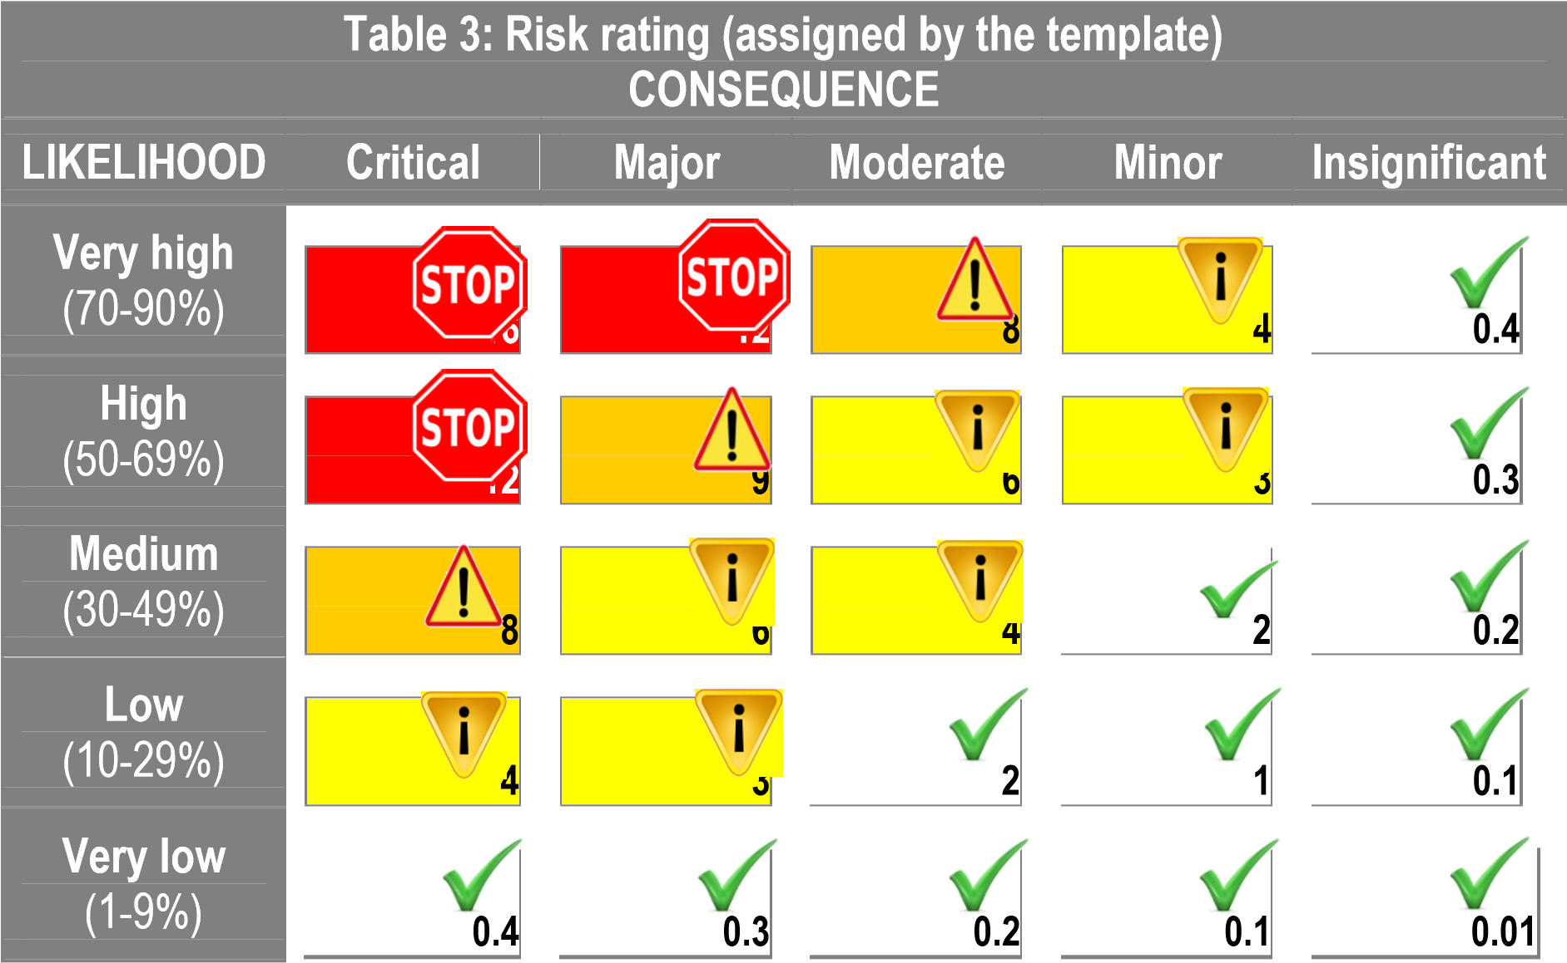

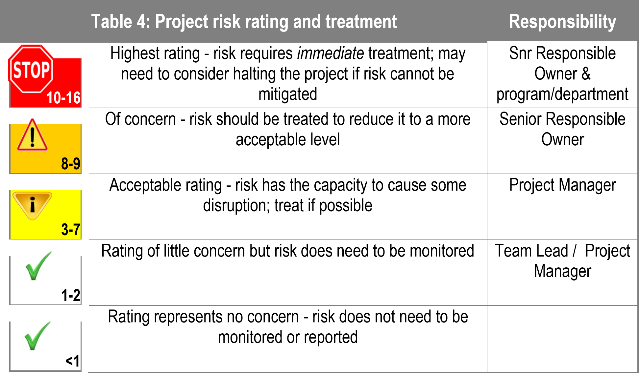

** The community-based plan will be developed through comprehensive community consultation, and may not be restricted to a single document; the ‘plan’ may also include frameworks, strategies, actions and/or solutions.

